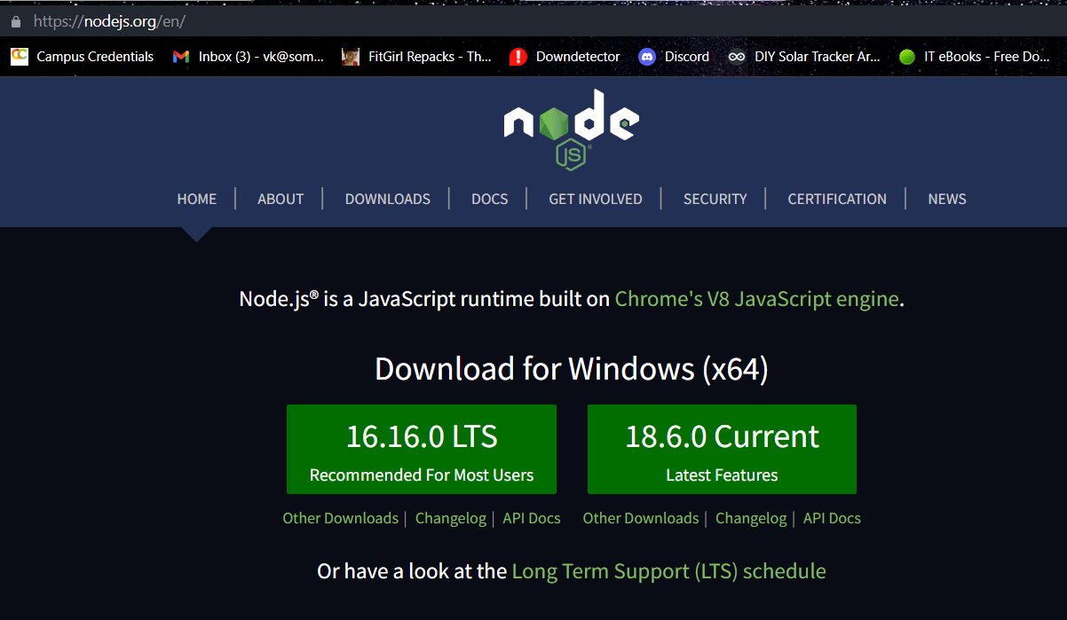

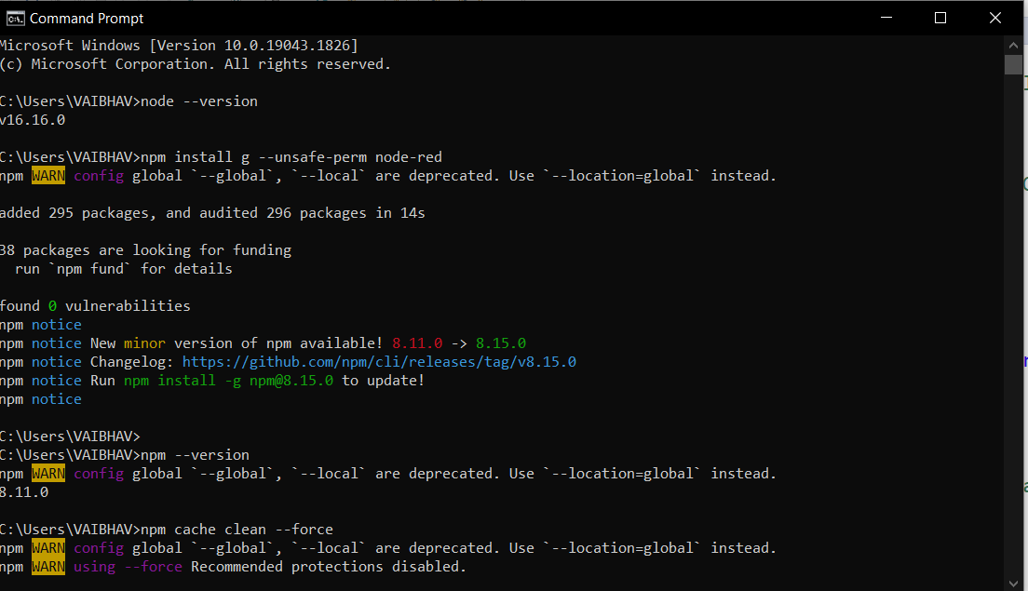

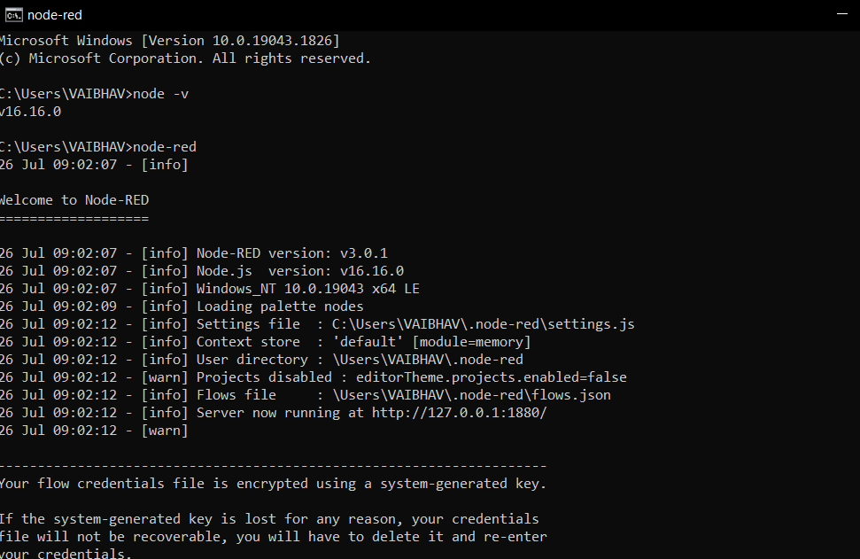

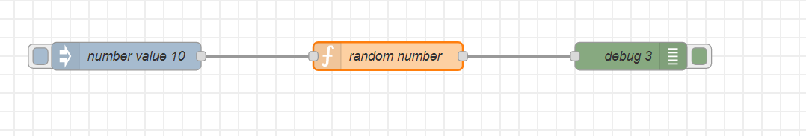

Install pallet

node-red-contrib-cpu

node-red-dashboard

